Riassunto OPT

# Relations

## Decision problem

P = (X, Ω, F, f, D, Π)

* X: feasible solutions;
* Ω: is the set of all possible scenarios (sample space)
* F: is the set of all possible impacts (indicator space);
* f : X × Ω → F is the impact function
* D: set of all decision-makers
* Π : D → 2 F ×F is a function that associates to each decision-maker d ∈ D a subset of impact pairs, Π (d) ⊆ F × F; this subset is intepreted as a binary relation and represents the preference of decision-maker.

Reflexive 🡪 Every impact is preferable to itself

Anti-symmetry 🡪 two impact are indifferent when they are exactly equal.

Completeness 🡪 If an impact is not preferable to another, then certainly the second one is preferable to the first one.

Transitivity 🡪 impact f is preferable to f’ and f’ preferable to f”, then f is preferable to f’’

Preorder 🡪 reflexive, transitive

Weak Order 🡪 reflexive, transitive, complete.

Parzial Order 🡪 reflexive, transitive, anti-symmetric.

Total order 🡪 reflexive, transitive, anti-symmetry, completeness.

## Value function

Una funzione valore associa ad ogni impatto f un valore reale. Quando una relazione di preferenza ammette una funzione valore, allora è di ordine debole. Esistono ordini deboli non riconducibili a funzioni valore, come l'ordine lessicografico.

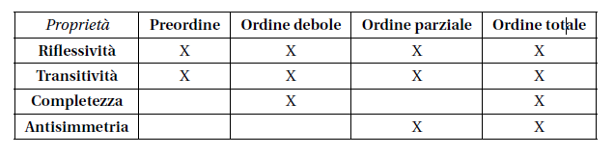

# Pareto

## Paretian impact

f <= f’ <=> f­­l <= fl’ ∀ l ∈ {1, …, p}

* An impact is preferable to another if all elements of the first do not exceed the second (in case of cost).

## Paretian dominance

* Paretian dominance 🡪 elements of one are strictly preferred to the impact of the latter

## Paretian Solution

* Paretian Solutions 🡪 Are not preferable to all other solution (not like global optimum)

## Identify Paretian region

1. Definition 🡪 Grafo dominanza delle soluzioni
2. Inverse transformation 🡪 Graficamente con l’inversa degli indicatori
3. Karush-Kuhn-Tucker 🡪 Utilizzo del metodo KKT
4. Weighted sum 🡪 Convex combination of the indicator and then takes the minimum.
5. ε – Constrains 🡪 take one or more indicator and constrain it with an ε parameter.

**Definition**

In a finite case, is possible to find the Paretian region using a dominance graph of the solution.

**Inverse transformation**

Only 2 indicators. First get the inverse of the function of the indicators and then you resolve the problem of space indicators substituting the optimal solution found in the solution space.

**Karush-Kuhn-Tucker**

In continuous case, apply the KKT condition proceed with a overestimation of the Paretian region.

1. ϕ : F 🡪 X
2. Sostituire x =  ϕ(f)
3. Determinare F° ovvero X° in the indicators space.
4. ϕ : F🡪X la regione paretiana X°.

**Weighted sum**

Apply a convex combination of the indicators of a impact and then minimise these combinations

$Z =\sum_{i=0}^{p}{f_{i}w_{i}}$ $\sum_{i}{w_{i}=1} ∀ w_{i}>0$

If x° global optimum in X respect to Z is globally Paretian.

ε **- constraints**

Take one or more indicators and then transform it in a inequality constrained by an ε coefficient. Then, is possible to solve it with KKT or graphically.

$$\min{f_{l}} \\ f_{l}≤ε l ϵ \left\{1,.. p \right\}\backslash \{l^{*}\}$$

Give a candidate but is not certainly a Paretian.

# Metodi a razionalità debole

Matrice dei confronti a coppie (Pairwise comparison matrix) 🡪 

Matrix that contains rate of estimations between normalised utilities.

## Rate of substitution

Rate of value between two indicators.

## Consistent ratio

* **Positivity**

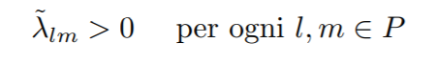

* **Reciprocity**

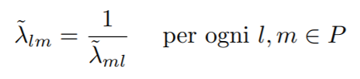

* **Consistency**

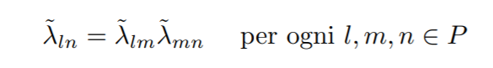

If Matrix is coherent is sufficient to normalize every column 🡺weights vector

## Eigen value method

Dominant eigenvalue umax is real and positive. Xmax (eigenvector) normalized produce a weights vector with is possible to build a coherent matrix.  
**CRITICS 🡺 produce dominated matrix**

# AHP ( Analytic hierarchy process )

## Criticism versus classical:

* Reconstruction of the single utility is subjected to an approximation errors
* The estimation of the weight vector is subject to approximation errors when attribute are large.
* Approximation errors combine in cascade.

## Characteristics:

1. Pairwise comparison to evaluate utility instead of absolute measures.
2. Use of qualitative scale 🡪 numeral value
3. Evaluation of weights pairwise 🡪 combine in additive way evaluation
4. Hierarchical structuring of attributes 🡪 hierarchical relation between homogeneous attributes.
5. Multiplicative recombination of weights at different level of hierarchy. 🡪 With tree I adjust the weights progressively ( from leaves to root).

## Rank reversal

Main problem of AHP 🡺 order of alternative depends on what alternative are present. Removing worst solution influence the order.

Solution: **Comparison between class and no single alternatives**

## Critical factors

* Applicable only on finite problem with small number of solutions
* Rank reversal

# ELECTRE

## Criticism

Decision maker can’t compare all pair of impact (Coffee paradox)

## Outranking relation

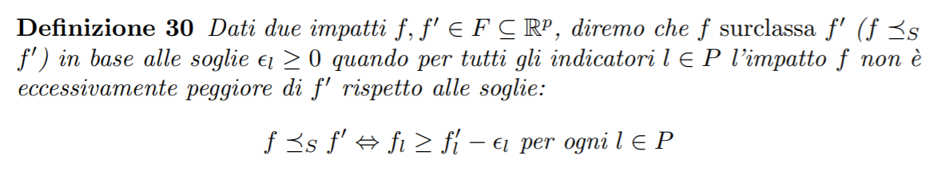

Impact f outrank f’ not only when all attributes are better, but also when it’s worse for a certain value ε.

## Refinement of outranking

Add weights for each indicator: an impact is considered preferable to another when the indicators with respect to which it is better have larger weights.   
(: un impatto sarà considerato tanto più preferibile a un altro quanto maggiore `e il peso degli indicatori rispetto ai quali `e migliore.)

W+ / w= / w-

## Condition of outranking

1. **Concordance**: a subset of attribute of sufficient weight agree that f is not worse than f’.
2. **Discordance**: no attribute rejects that f is better than f’
3. **Satisfaction of comparability threshold(soglie):** f is not much worse than f’ for every attribute.

## Kernel

1. Empty kernel
2. Add subset solution with no ingoing arc to the kernel
3. Remove all solution outranked by kernel function
4. If graph contains the kernel STOP; else goto 2.

# Decision in condition of ignorance

## Strong dominance

When alternative has an impact that is good in every scenario $ω∈Ω$ and best in at least one.

## Worst - Wald criteria

Worst = min max f(x,w) as a cost

## Best criteria

Best = min min f(x,w)

## Hurwicz

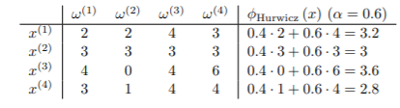

H = min [a worst + (1-a) best]

## LaPlace - Equiprobability

LaPlace= min E[sum of cost]/number of scenario

## Regret – Savage

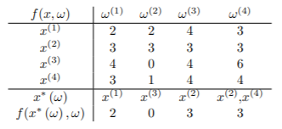 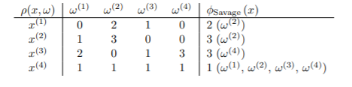

Savage = min max [f(x,w) – min]

Savage Benefit = min max [max – f(x,w)]

## Surplus

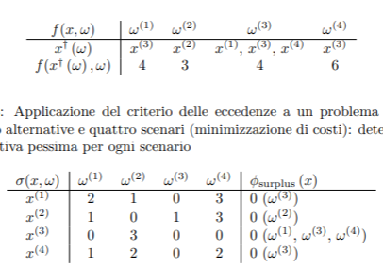 

Surplus = max min [ max – f(x,w]

Surplus Benefit = max min [ f(x,w) - min ]

# Condition of risk

## Expeceted value



## Lottery

A finite lottery is a pair of function f and π. f is a random variable defined on a finite sample space and π(w) the probability of a certain scenario w.

## Degenerate lottery

Only one impact is certain (with probability equals to 1).

## Compound lottery

Lottery in which impacts are other lotteries.

## Stochastic utility

Fundamental Axioms:

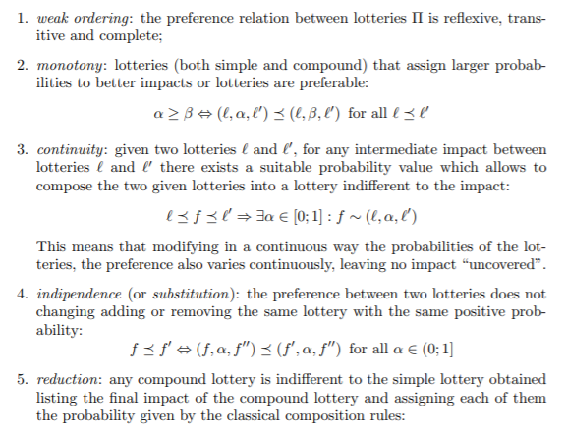

F impacts and π preference relation between lotteries on F that satisfy fundamental axioms, then exist one utility function π.

## Risk profile

1. Concave function 🡪 risk adverse
2. Linear function 🡪 risk indifferent
3. Convex function 🡪 risk prone